**VoiceSpeak iOS App - Țiu Cătălin**

***Idea***

The iOS app is meant to be used as a helpful travel companion by people with visual impairments whenever they need help abroad but do not speak the language or have helpers close at hand.

***Usage***

Users open the app whenever they need a translation and press the record button. Once they or their speakin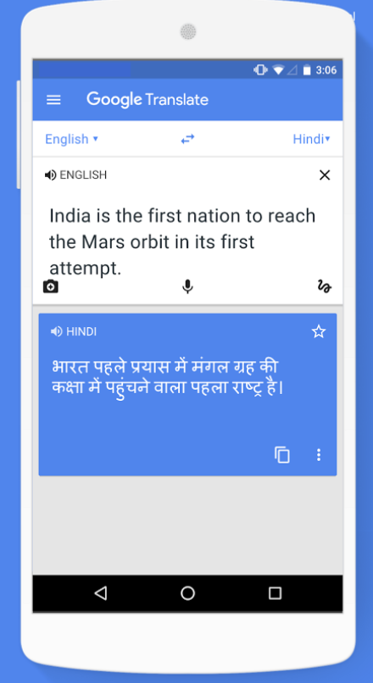g partner finish talking, they press the button once more and then the translated speech plays on the phone.

***Market alternatives***

There are more complex alternative apps on the market, the best-known being ***Google Translate,*** which offers hundreds of languages and synonym phrases for the user to have at his disposal.

Another well-known example is ***iTranslate,*** which has more reliable translations than Google Translate, but not as many languages.

The disadvantages to using these apps compared to my app are that the UI of the apps above is too complicated a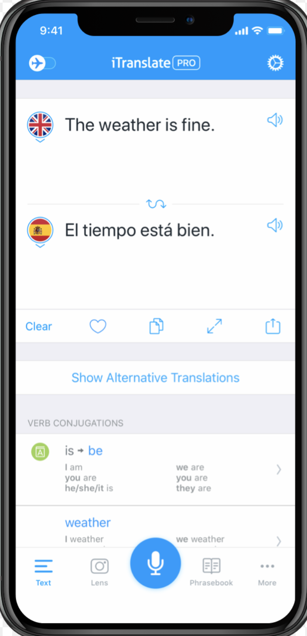nd crowded for a visually-impaired person to use reliably and with ease every time he needs a phrase translated. Also, the apps above focus on text translation rather than speech translation, making it for users more complicated to to directly translate a phrase through speech.

***Functionality***

The app consists of one main screen with a single button named “Start Recording”. The UI is very simplistic and easy to understand and use. Once pressed, the button changes into a “Stop Recording” button.

When the button is pressed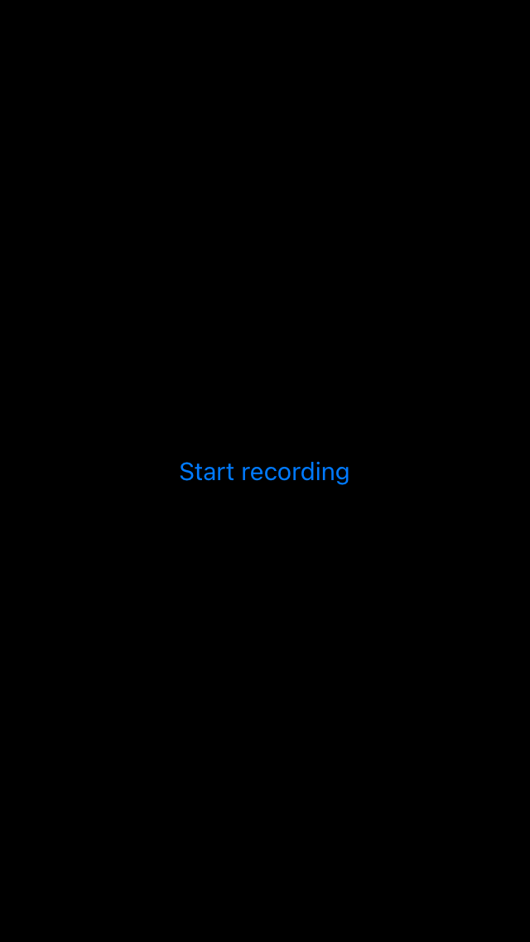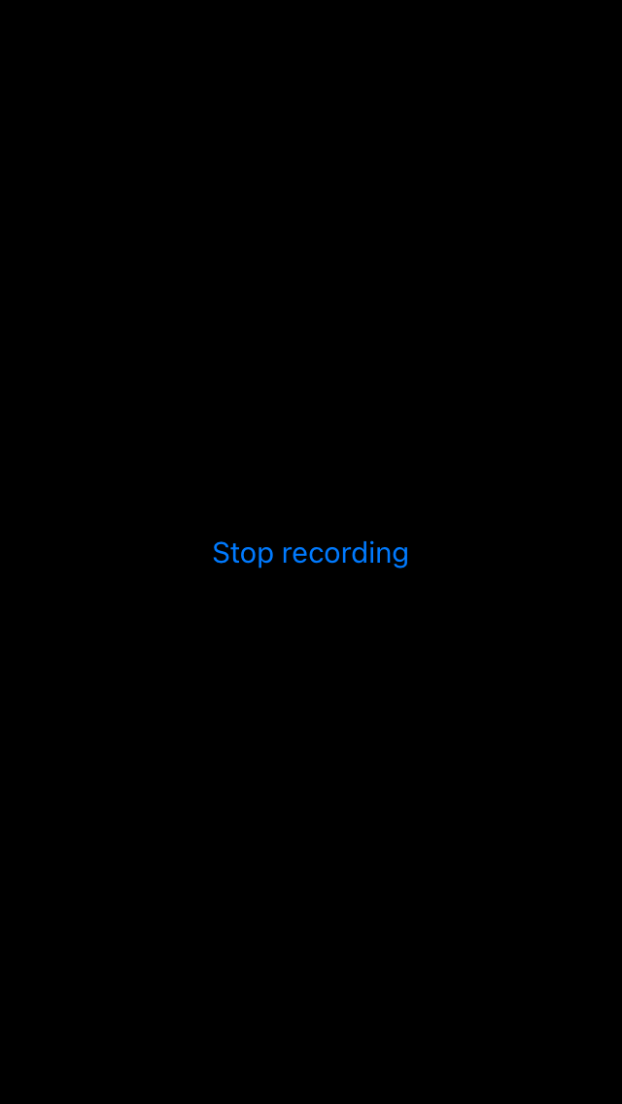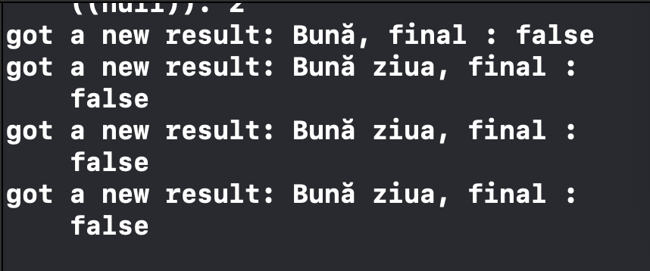 for the very first time, the app asks the user permission to access the microphone, and all the data( including the words and voice recorded) is handled locally, for the privacy of the user. While recording, the words spoken are saved in an array in its respective language.

When the button is pressed for a second time, the app stops using the microphone and the newly formed array is shown on the screen so the user can check the accuracy of the app so that they may try speaking again if the app did not manage to pick up their words correctly.

After that, the array 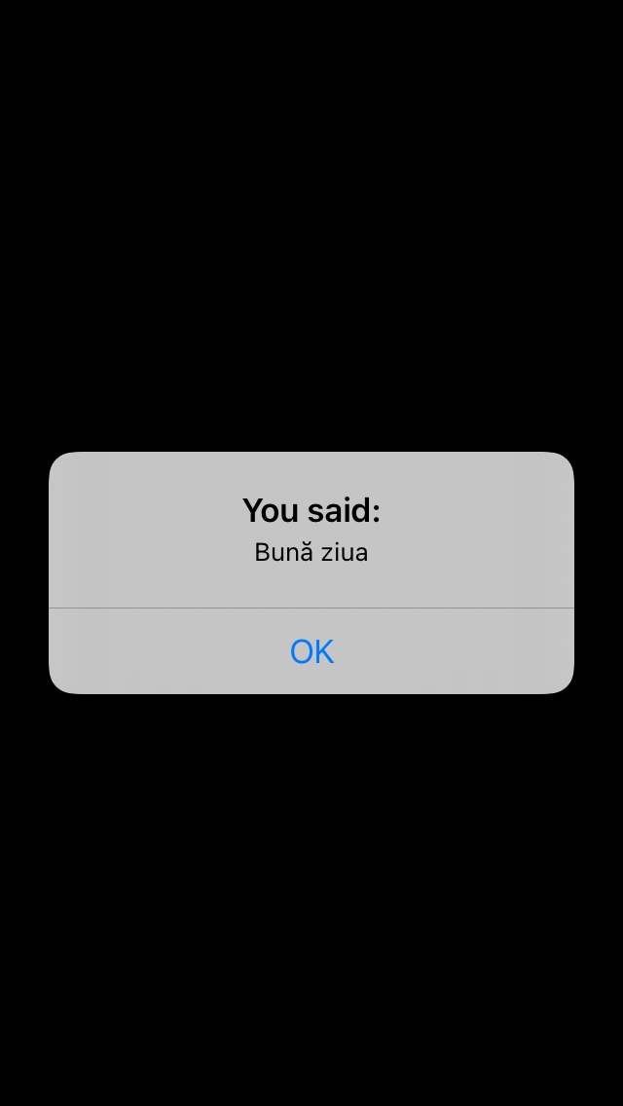is compared with all the words and phrases found in a local downloaded dictionary in a chosen language from the ML Kit API on iOS. The translated phrases are then put in a new array.

The new array is fed into the SynthesizerAV API which plays out the previously recorded audio into the new language chosen from the ML Kit API.